
Dissertation on

Generative AI in marketing

Submitted in partial fulfilment of the requirements for the award of degree of

Bachelor of Technology
in
Computer Science & Engineering

UE22CS320B – Capstone Project Phase - 2

Submitted by:

Srishti Mathur  Hrishita Patra  Dhruva R Prasad  Suhani Verma | PES1UG22CS614  PES1UG22CS241  PES1UG22CS186  PES1UG22CS623

Under the guidance of

Dr. Shylaja S.S
Director of Cloud Computing & Big Data (CCBD), Centre for Data Sciences & Applied Machine Learning (CDSAML)
PES University

January - May 2025

DEPARTMENT OF COMPUTER SCIENCE AND ENGINEERING
FACULTY OF ENGINEERING
PES UNIVERSITY

(Established under Karnataka Act No. 16 of 2013)

100ft Ring Road, Bengaluru – 560 085, Karnataka, India

PES UNIVERSITY

(Established under Karnataka Act No. 16 of 2013)
100 Feet Ring Road, Bengaluru – 560 085, Karnataka, India

FACULTY OF ENGINEERING

CERTIFICATE

This is to certify that the dissertation entitled

Generative AI in marketing

is a bonafide work carried out by

Srishti Mathur  Hrishita Patra  Dhruva R Prasad  Suhani Verma | PES1UG22CS614  PES1UG22CS241  PES1UG22CS186  PES1UG22CS623

in partial fulfilment for the completion of sixth semester Capstone Project Phase - 2 (UE22CS320B) in the Program of Study - Bachelor of Technology in Computer Science and Engineering under rules and regulations of PES University, Bengaluru during the period Jan. 2025 – May. 2025. It is certified that all corrections / suggestions indicated for internal assessment have been incorporated in the report. The dissertation has been approved as it satisfies the 6th semester academic requirements in respect of project work.
Signature  Dr. Shylaja S.S  Director of Cloud Computing & Big Data (CCBD), Centre for Data Sciences & Applied Machine Learning (CDSAML) | Signature  Dr. Mamatha H R  Chairperson | Signature  Dr. K S Sridhar  Registrar

External Viva
Name of the Examiners  1. __________________________  2. __________________________ | Signature with Date  __________________________  __________________________

DECLARATION

We hereby declare that the Capstone Project Phase - 2 entitled “Generative AI in marketing” has been carried out by us under the guidance of Dr. Shylaja S.S,Director of Cloud Computing & Big Data (CCBD), Centre for Data Sciences & Applied Machine Learning (CDSAML) and submitted in partial fulfilment of the course requirements for the award of degree of Bachelor of Technology in Computer Science and Engineering of PES University, Bengaluru during the academic semester Jan - May 2025. The matter embodied in this report has not been submitted to any other university or institution for the award of any degree.

PES1UG22CS614 | Srishti Mathur
PES1UG22CS241 | Hrishita Patra
PES1UG22CS186 | Dhruva R Prasad
PES1UG22CS623 | Suhani Verma

ACKNOWLEDGEMENT

I would like to express my gratitude to Dr. Shylaja S.S, Department of Computer Science and Engineering, PES University, for her continuous guidance, assistance, and encouragement throughout the development of this UE22CS320B - Capstone Project Phase – 2.
I am grateful to the project coordinator, Dr Priyanka H, for organizing, managing, and helping with the entire process.
I take this opportunity to thank Dr. Mamatha H R, Chairperson, Department of Computer Science and Engineering, PES University, for all the knowledge and support I have received from the department. I would like to thank Dr. K.S. Sridhar, Registrar, PES University, for his help.
I am deeply grateful to Prof. Jawahar Doreswamy, Chancellor – PES University, Dr. Suryaprasad J, Vice-Chancellor, PES University, for providing me various opportunities and enlightenment every step of the way. Finally, this project could not have been completed without the continual support and encouragement I have received from my family and friends.

ABSTRACT

The digital marketing industry is increasingly adopting generative artificial intelligence (AI) to address the inefficiencies of manual, resource-heavy ad creation. This report introduces a Generative AI Marketing Application that automates end-to-end advertisement production by integrating machine learning (ML), natural language processing (NLP), and computer vision. Leveraging state-of-the-art models like Stable Diffusion, the system synthesizes brand-aligned creatives—from persuasive copy to multimedia visuals—to meet demands for scalability, personalization, and agility. By analyzing real-time consumer behavior, market trends, and historical data, it generates dynamic, contextually relevant ads tailored to diverse audiences while streamlining workflows and reducing production costs.
The application incorporates ethical safeguards to mitigate risks like algorithmic bias and misinformation, ensuring brand consistency and safety. This report evaluates its technical architecture, creative efficacy, and challenges in balancing automation with human creativity. The findings highlight generative AI’s potential to redefine advertising efficiency, offering businesses a competitive edge in the fast-evolving digital marketplace through data-driven, cost-effective campaigns.

TABLE OF CONTENTS

Chapter No. | Title | Page No.
 | INTRODUCTION | 01
 | PROBLEM DEFINITION | 02
 | DATA  4.1 Overview  4.2 Dataset | 03
 | DESIGN DETAILS  4.1 Novelty  4.2 Innovativeness  4.3 Interoperability  4.4 Performance  4.5 Security  4.6 Reliability  4.7 Maintainability  4.8 Portability  4.9 Legacy to Modernization  4.10 Reusability  4.11 Application Compatibility  4.12 Resource Utilization | 04-08
 | HIGH LEVEL SYSTEM DESIGN /SYSTEM ARCHITECTURE  5.1 Frontend (Web Interface)  5.2 Api Gateway / Backend Service  5.3 Image Preprocessor  5.4 Prompt Generator  5.5 Stable Diffusion (In-Painting)  5.6 Ad-Renderer | 09-10
 | DESIGN DESCRIPTION  6.1 Master Class Diagram  6.2. ER Diagram / Swimlane Diagram / State Diagram  6.3 User Interface Diagrams  6.4. Report Layouts  6.5. External Interfaces  6.6. Packaging and Deployment Diagram | 11-16
 | TECHNOLOGIES USED | 17-19
 | DATA PREPROCESSING AND IMPLEMENTATION | 20
 | CONCLUSION OF CAPSTONE PROJECT PHASE - 2 | 21
 | PLAN OF WORK FOR CAPSTONE PROJECT PHASE - 3 | 22
REFERENCES/BIBLIOGRAPHY |  | 23
PLAGIARISM REPORT |  | 24

LIST OF FIGURES

Figure No. | Title | Page No.
1 | High level Architecture Overview Diagram | 9
2 | Mater Class diagram | 11
3 | ER Diagram | 12
4 | Swimlane Diagram | 12
5 | State Diagram | 13
6 | User Interface Diagram | 14
7 | Report Layout Diagram | 14
8 | External Interface Diagram | 15
9 | Packaging and Deployment Diagram | 16
10 | Ad Generation Context Form Diagram | 18
11 | Captured Context and Output Diagram | 18

LIST OF TABLES

Table No. | Title | Page No.
1. | Dataset | 03

CHAPTER-1

INTRODUCTION

The digital marketing landscape is undergoing a transformative shift with the emergence of generative artificial intelligence (AI), which combines machine learning (ML) and strategic business intelligence to redefine how brands engage with audiences. Traditional marketing workflows often struggle with scalability, personalization, and the rapid iteration required to keep pace with dynamic consumer preferences. This project introduces a Generative AI Marketing Application designed to automate and optimize advertising campaigns by synthesizing creativity, data analytics, and brand strategy into a unified framework.

Modern businesses face mounting pressure to deliver hyper-targeted, high-impact ads across ever-evolving digital platforms, yet manual content creation remains time-consuming and resource-intensive. By leveraging state-of-the-art generative AI models—including large language models (LLMs) like Mistral-7B-Instruct-v0.1 Large Language Model (LLM) and diffusion-based image generators like Stable Diffusion—this application autonomously generates compelling ad creatives, from persuasive copy to visually engaging multimedia content.

However, the adoption of generative AI in marketing also raises critical challenges, including ethical concerns around misinformation, algorithmic bias, and the need for human oversight to ensure brand safety. This report explores these complexities while demonstrating how AI-driven marketing tools can unlock unprecedented efficiency, creativity, and ROI, positioning businesses at the forefront of the advertising revolution.

CHAPTER-2

PROBLEM DEFINITION
The digital advertising industry faces significant challenges in meeting the escalating demand for scalable, personalized, and agile marketing campaigns. Traditional ad creation processes rely heavily on manual labor, requiring marketers to ideate, design, and test content across multiple platforms—a time-consuming and resource-intensive workflow. This approach struggles to keep pace with dynamic consumer preferences, real-time market trends, and the need for rapid iteration. Additionally, fragmented tools for copywriting, visual design, and audience targeting often lead to disjointed campaigns, brand inconsistency, and inefficient resource allocation.
Current solutions lack integration between creativity and data-driven decision-making, resulting in generic advertisements that fail to resonate with diverse audience segments. The reliance on human effort also introduces bottlenecks, limiting scalability and increasing costs for businesses. Furthermore, the rise of AI-generated content raises ethical concerns, such as algorithmic bias, misinformation risks, and challenges in maintaining brand safety. These gaps highlight the urgent need for an automated, end-to-end solution that combines generative AI’s creative potential with robust safeguards to deliver efficient, ethical, and impactful advertising at scale.

CHAPTER-3

DATA

Overview
The Fashion Product Images Dataset by Param Aggarwal (Kaggle) comprises ~44,000 fashion products with metadata (e.g., gender, category, color, season, usage, and descriptive productDisplayName) and matching low-resolution images (60x80px PNGs). Designed for tasks like visual recognition, recommendation systems, and generative AI applications, this dataset supports marketing use cases by enabling multimodal AI training—combining product visuals with contextual text (e.g., “Pink Floral Dress for Summer”) to automate ad creatives, personalize campaigns based on attributes like demographics or trends, and ensure brand-aligned outputs across diverse apparel and accessories categories.
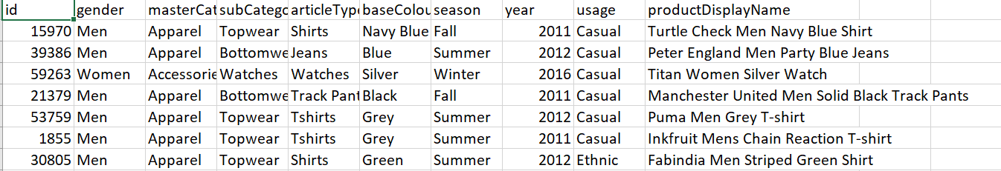

Dataset :-
https://www.kaggle.com/datasets/paramaggarwal/fashion-product-images-dataset

CHAPTER-4

DESIGN DESCRIPTION

4.1 Novelty:Unified Multi-Modal Ad Generation
  - Unlike existing tools that specialize in isolated tasks (e.g., text-only or image-only generation), this application integrates text, visuals, and multimedia into a seamless workflow, producing cohesive, platform-ready advertisements.
  - Combines large language models (LLMs) like Mistral-7B-Instruct-v0.1 Large Language Model (LLM) with diffusion-based image generators (Stable Diffusion) to ensure brand-consistent creatives across formats.
- Contextual and Brand-Aware AI
  - Introduces a dynamic feedback loop where AI-generated content is refined using real-time consumer engagement data (e.g., click-through rates, social media interactions), enabling ads to evolve with audience preferences.
  - Incorporates natural language understanding (NLU) to interpret brand guidelines (tone, style, values) and ensure generated content aligns with corporate identity.

4.2 Innovativeness:
1.Scalable Personalization
  - Enables hyper-personalized ad variations at scale by analyzing granular audience segments (demographics, browsing history), overcoming the "one-size-fits-all" limitation of traditional marketing.
- Human-AI Collaborative Workflow
  - Introduces a hybrid workflow where marketers interactively refine AI outputs (e.g., tweak copy, adjust visuals) without disrupting the automation pipeline, blending human creativity with machine efficiency.
- Cross-Platform Optimization
  - Automatically adapts generated ads to platform-specific requirements (e.g., Instagram stories vs. Google Display Ads), optimizing aspect ratios, text lengths, and visual styles—eliminating manual reformatting.
- Democratization of Advanced Marketing
  - Makes enterprise-level ad creation accessible to small and medium businesses (SMBs) by reducing costs, technical expertise barriers, and production time traditionally associated with high-quality campaigns.

4.3 Interoperability
Interoperability in the system exists with smooth interoperability of a range of new-generation AI devices and technologies. The system employs a language model (Mistral-7B-Instruct-v0.1) for text generation corresponding to the input prompt and diffusion-image generation model (Stable Diffusion) for generating multimedia ad creatives. The framework maximizes interoperability between such sections as prompt engineering, advert generation through engagement of building blocks.
4.4 Performance
The application substantially improves performance with reduced human effort and manual thinking time. With optimized AI models, it enables quicker response, allowing large-scale ad campaigns across millions of digital media users to be executed with low latency.

4.5 Security
Security measures are integrated into the design, particularly through the adoption of generative AI. The system ensures to circumvent risk against disinformation, brand inconsistency, and algorithmic bias. Human-in-the-loop audit and verification processes are utilized, and through them, the app safeguards brand identity and user trust. Secure input data handling—like user-input prompts and behavioral analytics—forms a significant design aspect, as per data protection laws and AI mindfulness ethics.

4.6 Reliability
Reliability is achieved through the repeatable generation of brand-conformant(based on certain user inputs), high-quality creatives. Utilizing thoroughly documented and tried models such as Mistral-7B and Stable Diffusion minimizes failure risk and likelihood of inconsistency in output. Modular architecture also facilitates fault isolation and recovery;minimizing downtime and maximizing availability of the application.

4.7 Maintainability
Maintainability is a fundamental resource of this project, achievable due to modularity and layering in its architecture. Any module—like the prompt generator, image generator—can be replaced or updated independently. Software developers can therefore update AI models or embed new rules for marketing(more inputs) without affecting the system as a whole.API standardization make testing, debugging, and providing long-term support easier.

4.8 Portability
As a web-based application, the solution is portable over various hardware and software platforms. It can be deployed in cloud-based systems, company local servers, or blended configurations with few reworks. With access via stable APIs, moving between development, testing, and production environments becomes flawless with guaranteed access irrespective of the base infrastructure.

4.9 Legacy to Modernization
The application is an evolution of conventional marketing process to AI-backed processes. It simplifies creative development, heretofore labor-intensive and time-consuming, infusing speed, consistency, and smarts into ad campaign creation. With this, it allows businesses to update their marketing approaches, adopt data-driven decision-making, and compete within the digital-first economy of the present times.This particularly falls in favor for small scale businesses that do not want to invest too much in manual work and its burdening costs.

4.10 Reusability
The platform is built for facilitation of reusability. Prompt templates, generation modules and mechanisms can be reused in various campaigns, clients, or industries. The same AI elements which create content for a product can be modified with minor input differences to produce another. This modular reuse not only saves time-to-market but also lowers development and operational expenses in the long run.

4.11 Application Compatibility
The solution is made to be compatible with existing workflows and digital marketing platforms. It can be integrated with campaign management systems, CRM, performance analysis, and so forth, using APIs and plugin-based architecture. This way, organizations don't need to change their infrastructure to implement the solution—it fits into their current environments without too much disturbance.

4.12 Resource Utilization
Resource usage is optimized both in human and computing capabilities. With automated content generation, the platform minimizes dependence on creative departments for producing mundane ads so that the departments can be devoted to strategy and innovation. For computing, optimized usage of GPU and cloud resources facilitates rapid processing of generative workloads at optimal cost.

CHAPTER-5

HIGH LEVEL SYSTEM DESIGN /SYSTEM ARCHITECTURE
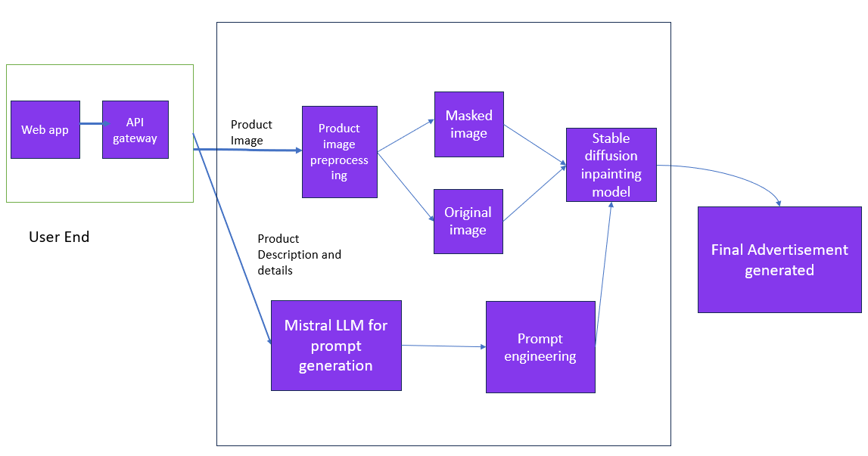
Fig 1. High level architecture overview diagram

The system is designed to automatically generate advertisement creatives using a combination of web-based user input, image processing, prompt engineering, and AI image generation through Stable Diffusion. It integrates a Mistral LLM model for generating high-quality textual prompts that guide the image generation process.

System Components :

5.1. Frontend (Web Interface)
Built with React / Angular / Vue with HTML, CSS, and JavaScript.
Allows users to upload product images, enter descriptions, and preview/download the final advertisement.

5.2. API Gateway / Backend Service
Handles request routing among components such as the image preprocessor, prompt generator (Mistral LLM), and Stable Diffusion. Built with Node.js / Flask / FastAPI with a RESTful API architecture.

5.3. Image Preprocessor
Uses OpenCV and Mask-RCNN to mask and segment the uploaded product image, readying it for error-free inpainting by the diffusion model.

5.4 Prompt Generator (Mistral LLM)
Converts user descriptions into novel prompts with Mistral-7B or Mistral-Instruct.

5.5. Stable Diffusion (Inpainting)
Takes masked image and LLM-created prompt to generate high-quality, inpainted ad image. Deployed on Kaggle's P100 GPU environment.

5.6. Ad Renderer / Output Module
Shows the final ad, saves it to cloud storage (e.g., S3), and offers download/sharing features.

CHAPTER 6

DESIGN DESCRIPTION

6.1 Master class diagram :

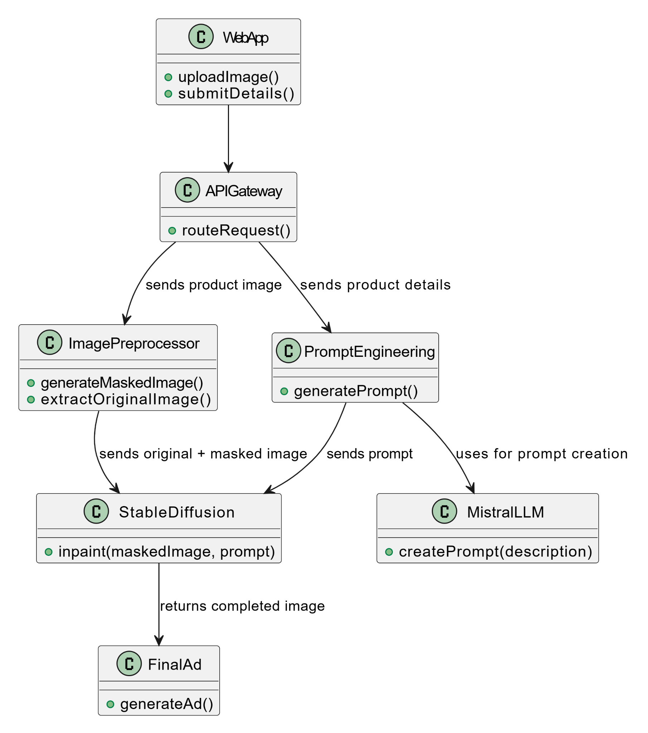

Fig 2. Master Class Diagram

6.2 ER Diagram

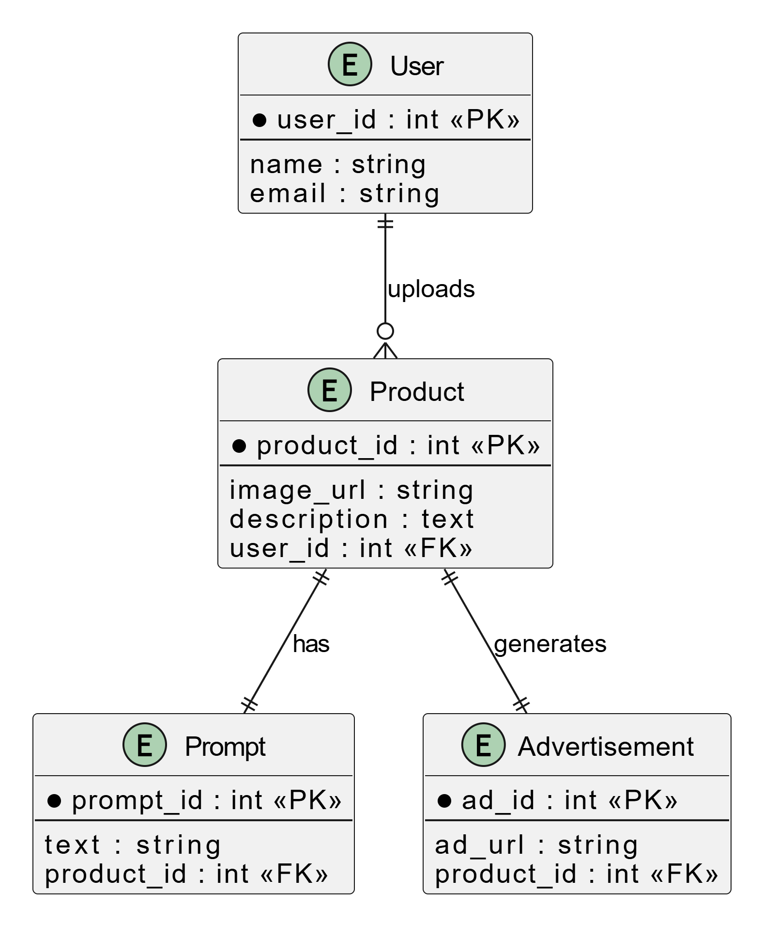

Fig 3. ER Diagram

6.3 Swimlane diagram

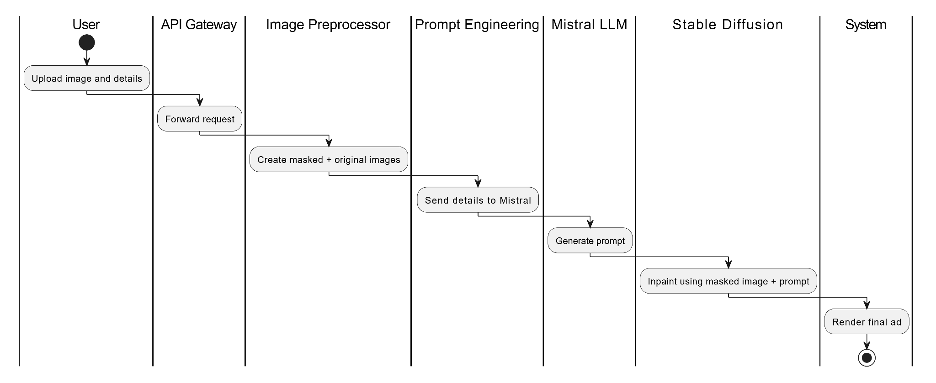

Fig 4. Swimlane Diagram

6.3 State Diagram

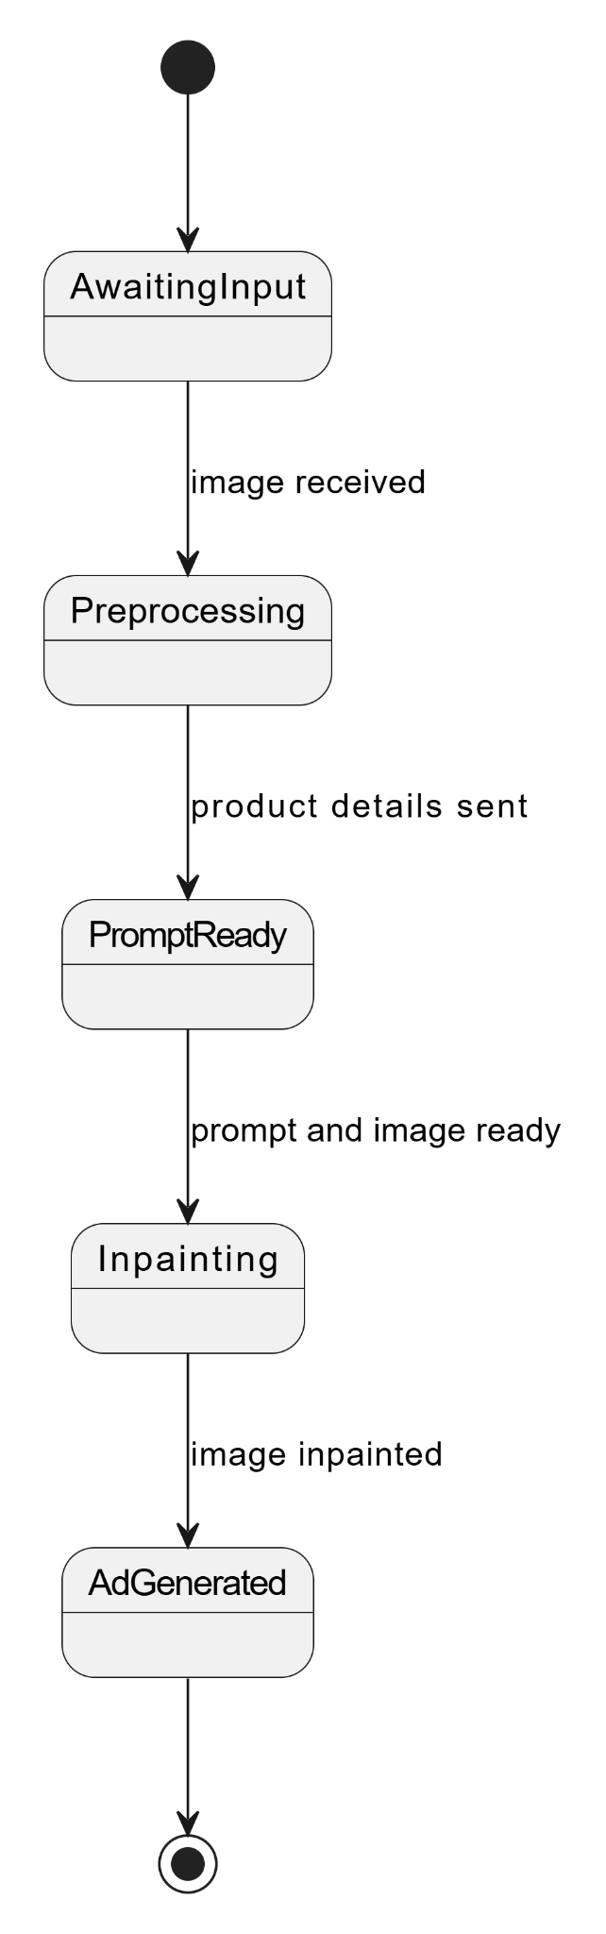

Fig 5. State Diagaram

6.4 User Interface Diagram

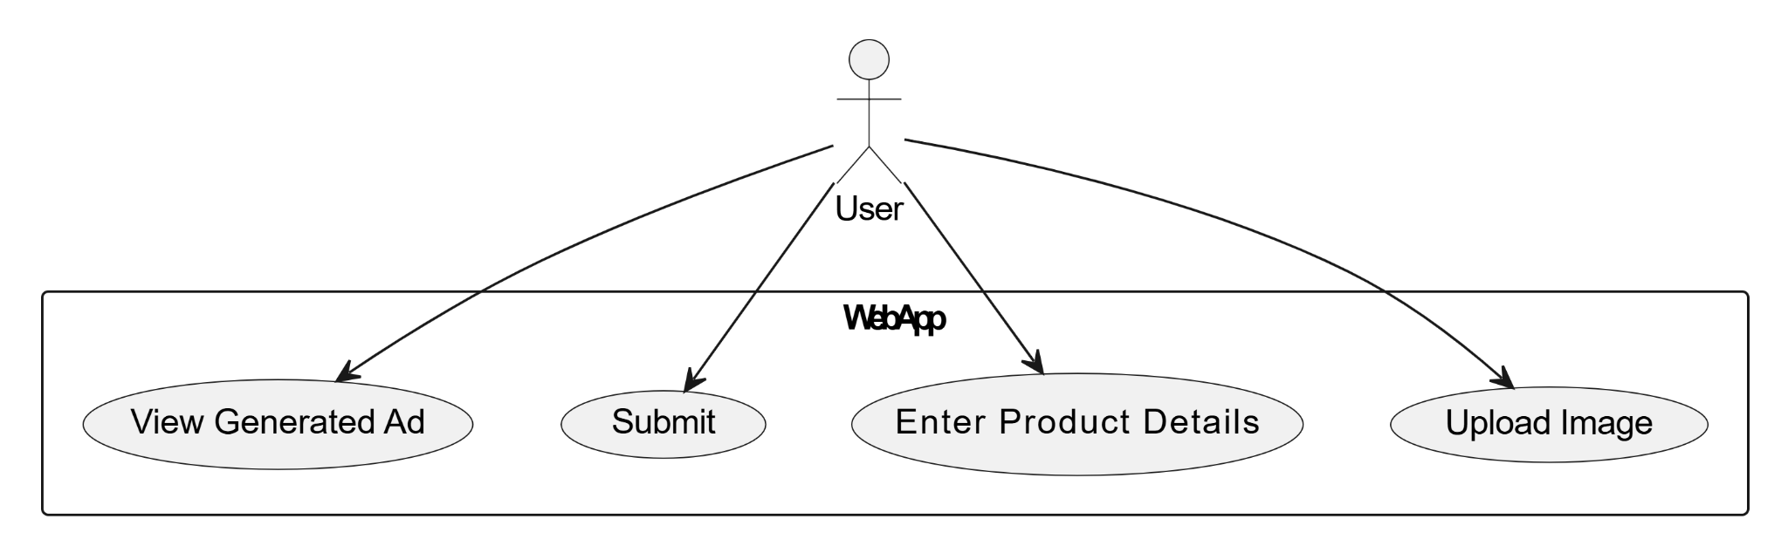

Fig 6. User Interface Diagram

6.5 Report layout diagram

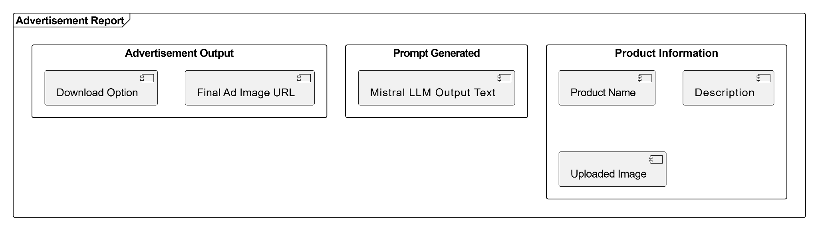

Fig 7. Report Layout Diagram

6.6 External interface diagram

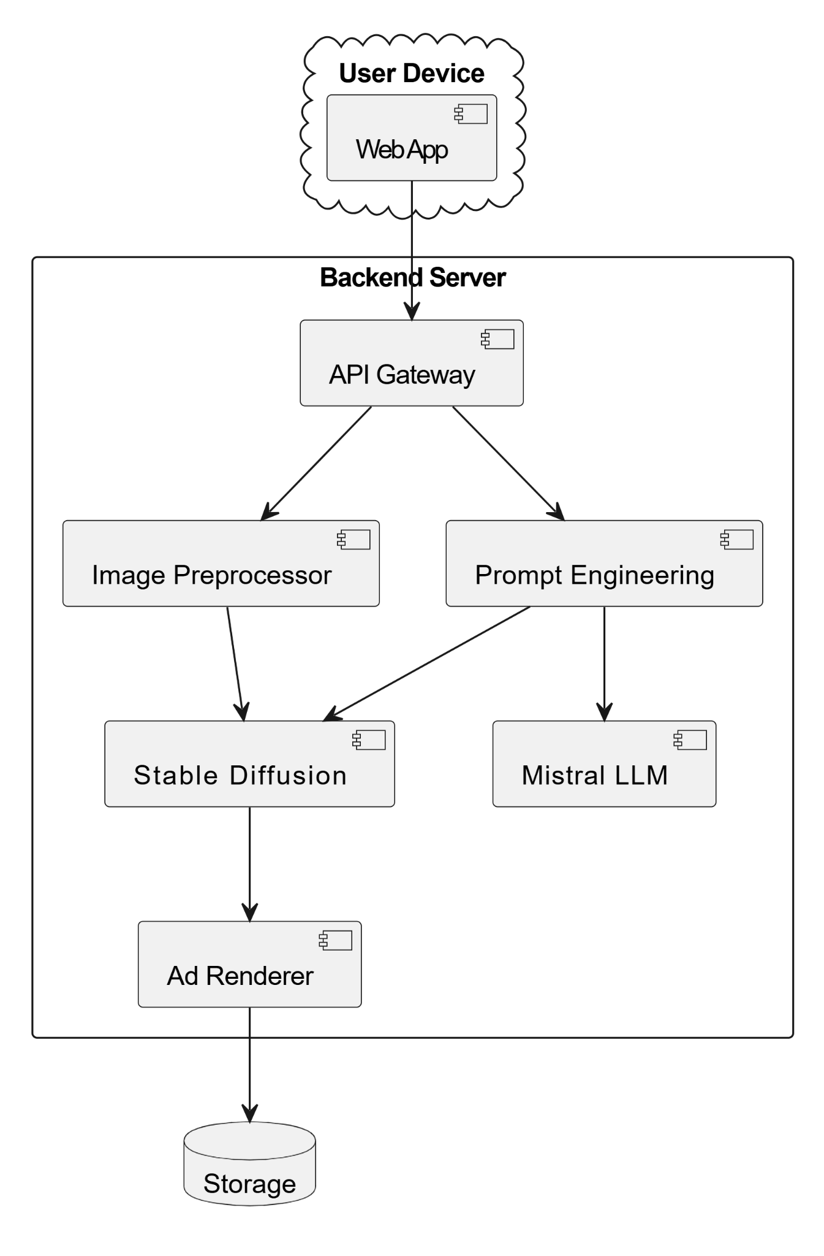

Fig 8. External Interface Diagram

6.7 Packaging and deployment diagram

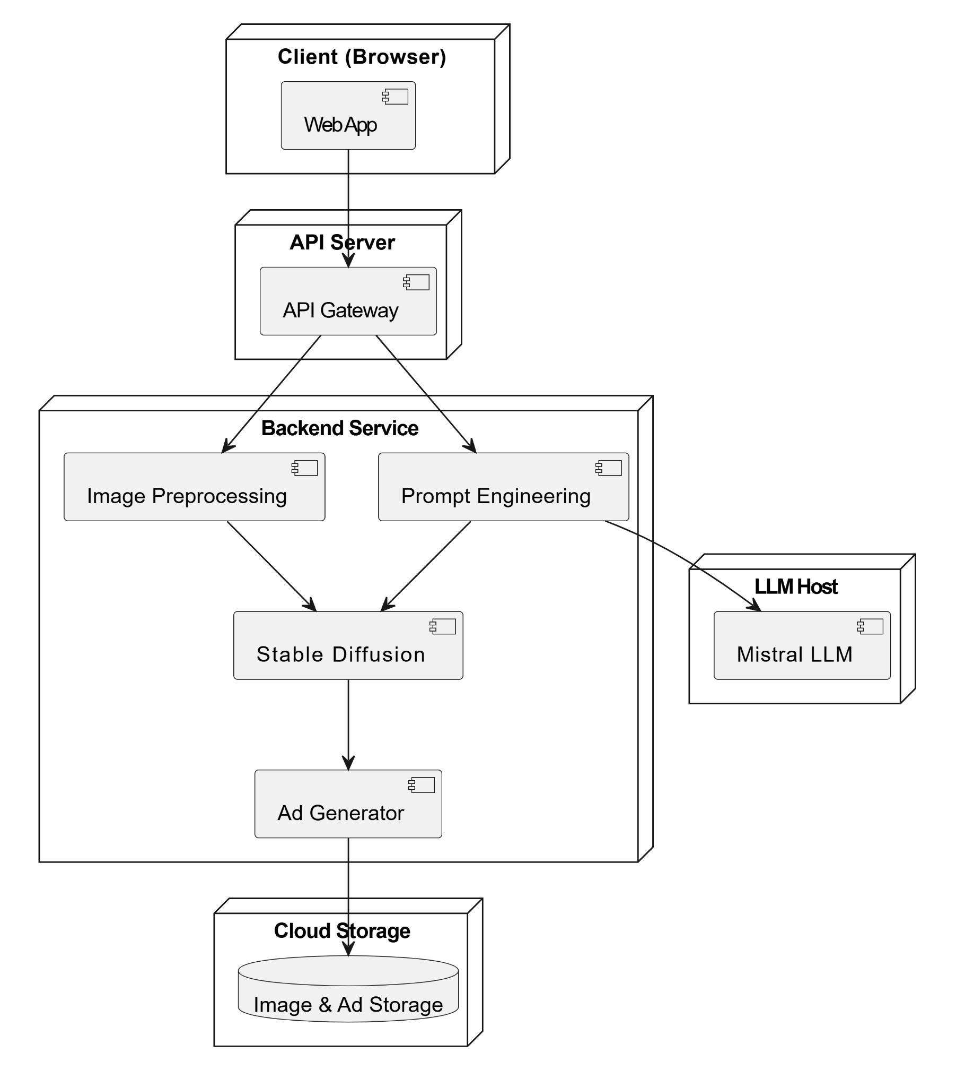

Fig 9. Packaging and Deployment Diagram

CHAPTER 7:

TECHNOLOGIES USED
7.1 Dynamic Placement Methods for Product Inlay
To make product placement look realistic and context-sensitive in AI-generated backgrounds, we employed the following dynamic methods:
1)Background Removal: The rembg library is used to cut out products from their source images, yielding clean, transparent layers for inlay.
2)Object Detection-Based Avoidance: With the YOLOv5 model (torch.hub), we detect objects such as people, animals, and trees in the background to avoid having products placed on top of visually significant areas.
3)Semantic Region Awareness: We made a segmentation map specifically designed to mimic sky and ground regions and used this to inform placement according to contextual zones (e.g., putting products on "ground"-like spaces instead of the sky).
4)Placement Scoring Algorithm: We established a scoring function taking into account brightness, texture variance, vertical bias, and semantic compatibility to identify the most visually appropriate placement for the product.
5)Shadow Simulation: Dynamic shadows were created using PIL and ImageFilter to increase realism and depth when inlaying the product onto the background.
7.2 UI Implementation

The user interface is intended to gather critical inputs which steer the generation of the prompt to generate background. These are inputs such as gender (where applicable), color theme, use context (e.g., casual, formal), sub-category, master category, and year. These factors are paired with a baseline prompt to create a fine-tuned, context-specific description utilized to generate the advertisement background.

When the last prompt is prepared, it is submitted to the Stable Diffusion model (RunwayML version) to create a pleasing and customized background that reflects the specifications of the user.

The interface itself is constructed by Gradio, which not only delivers a clean and interactive design but also makes the application accessible by way of a shareable public link.

There is work in progress for integrating effortless uploads of product images and having them displayed in the created backgrounds. This will create a total end-to-end product-inclusive advertisement visual creation within a module-friendly and easy-to-use setup.

Fig 10. Ad Generation Context Form diagram


Fig 11. Captured Context and Output diagram

7.3 Background generation
The system leverages a hybrid architecture combining RunwayML’s Stable Diffusion v1-5 (a text-to-image diffusion model) and Mistral 7B (a lightweight, high-performance LLM) to automate context-aware background creation. Mistral 7B acts as the prompt engineer, analyzing input data (e.g., product metadata like season, color, and usage from the Fashion Product Images Dataset) to generate highly descriptive, stylized text prompts (e.g., “A minimalist winter-themed background with soft blue gradients for a luxury women’s wool coat”). These prompts are fed into Stable Diffusion v1-5, which synthesizes photo realistic or stylized backgrounds aligned with the brand’s aesthetic and campaign goals.

CHAPTER 8 :

DATA PROCESSING AND IMPLEMENTATION

Used the styles.csv dataset, which contains metadata such as id, gender, masterCategory, subCategory, articleType, baseColour, season, and usage. Each product entry corresponds to an image named in the format id.jpg.
The metadata is used to craft contextual prompts that guide the generation of advertisement backgrounds. The corresponding product image is then dynamically embedded into the generated background.
To achieve this, we first preprocess the image by removing its original background using the rembg library. This isolates the product and provides a clean, transparent layer, which can then be inlaid into the generated scene.

CHAPTER 9

CONCLUSION -CAPSTONE PROJECT PHASE 2

1)Background Generation through Prompt Engineering: We use the Mistral LLM to produce advertisement backgrounds based on meticulously designed prompts derived from product metadata.
2)Context based prompt Design: Prompts are dynamically generated according to properties like gender, use, color, and category so that the background matches intended brand tone and aesthetic of the product.
3)Seamless Product Inlaying: We inlaid the original product image onto the created background preserving its visual quality and without deformation, allowing realistic ad composition.
4)Dynamic Product Placement with Object Detection: Applying YOLOv5 and segmentation scoring, we found optimal, non-overlapping spots on the background where the product was placed to add visual attractiveness while not obscuring important features.
5)User-Friendly Interface: A lean UI was created to enable users to enter product information ,automating the generation of a complete advertisement in a single workflow.

CHAPTER 10

PLAN OF WORK FOR CAPSTONE PROJECT PHASE - 3

In order to improve our advertisement generation system, we aim to implement the following features in the future-
1)UI Integration and Workflow Automation: Our goal is to improve the current user interface by allowing direct image upload as well as a complete integration of the end-to-end process—from entering product metadata to producing the final ad. The users will also be able to define what text they wish to see in the advertisement, making it easy to create personalized messages and improving the overall ad experience — all within a user-friendly platform.
2)Support for Additional Visual Elements: Future updates will add support for adding visual characters, props, or stylized brand assets to create more visually appealing and engaging advertisements..
3)Improved Background-Product Mapping: We plan to enhance contextual alignment between background and product through the improvement of our placement algorithms. This entails background texture compatibility optimization, lighting consistency, and perspective-aware placement for more consistent and professional-looking visual output

REFERENCES

[1] A. J.-B. Mazaré, M. Ramé, T. Lamarche, T. Luccioni, D. Simig, G. Ligner, T. Lavril, R. Tallec, T. Schatz, A. Bégué, and G. Lample, “Mistral 7B,” arXiv preprint arXiv:2310.06825, Oct. 2023. [Online]. Available: https://arxiv.org/abs/2310.06825

[2] R. Rombach, A. Blattmann, D. Lorenz, P. Esser, and B. Ommer, “High-Resolution Image Synthesis with Latent Diffusion Models,” arXiv preprint arXiv:2112.10752, Dec. 2021. [Online]. Available: https://arxiv.org/abs/2112.10752​GitHub+8

[3] P. Sahoo, A. K. Singh, S. Saha, V. Jain, S. Mondal, and A. Chadha, “A Systematic Survey of Prompt Engineering in Large Language Models: Techniques and Applications,” arXiv preprint arXiv:2402.07927, Feb. 2024. [Online]. Available: https://arxiv.org/abs/2402.07927​arXiv+6
[4] J. Redmon, S. Divvala, R. Girshick, and A. Farhadi, “You Only Look Once: Unified, Real-Time Object Detection,” arXiv preprint arXiv:1506.02640, May 2016. [Online]. Available: https://arxiv.org/abs/1506.02640

[5] S. Witteveen and M. Andrews, “Investigating Prompt Engineering in Diffusion Models,” arXiv preprint arXiv:2211.15462, Nov. 2022. [Online]. Available: https://arxiv.org/abs/2211.15462

[6] M. S. Seyfioglu, K. Bouyarmane, S. Kumar, A. Tavanaei, and I. B. Tutar, “DreamPaint: Few-Shot Inpainting of E-Commerce Items for Virtual Try-On without 3D Modeling,” arXiv preprint arXiv:2305.01257, May 2023. [Online]. Available: https://arxiv.org/abs/2305.01257​
[7] F. R. Perche-Mahlow, A. Felipe-Zanella, W. A. Cruz-Castañeda, and M. Amadeus, “An Inpainting-Infused Pipeline for Attire and Background Replacement,” arXiv preprint arXiv:2402.03501, Feb. 2024. [Online]. Available: https://arxiv.org/abs/2402.03501

PLAGIARISM REPORT

